1. Consider the circuit shown below:

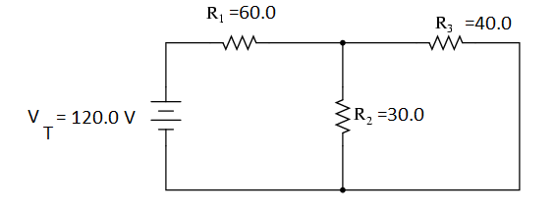

a) Solve for the total equivalent resistance in the circuit:

b) Find the total current flowing from the battery.

c) Find the voltage across each resistor and the current through each resistor.

c) Find the electrical power converted by resistor 1.

1. Explain the difference between conventional current and electron flow.
2. A light bulb with a current of 0.80 A and a resistance of 1.20x103 Ω is left running for 25 minutes.  
   1. How much electric charge passes through the light bulb?
   2. What is the power of the light bulb?
   3. How much energy is used by the light bulb?
3. Use Kirchoff’s Current and Voltage Laws to determine all unknown currents and voltages in the following circuit. Show your work in the space beside the diagram.

a) I4 = _______ I5 = _______ V3 = __________ V4 = ____________ V5 = _________

